SIMATS ENGINEERING

ASSESSMENT TOOL 3

COURSE NAME: Artificial Intelligence COURSE CODE: CSA17

COURSE OUTCOME COVERED

CO2: Experiment search and game-solving techniques such as Greedy Search, A*, CSP, Minimax, and Alpha-Beta pruning with heuristic functions for solving complex AI problems efficiently. (BL3)

Assessment Tool Weightage: 40%

Duration: 1 Hour
QUESTIONS: 3 Total Marks:30

Annexure A

Dry Run Evaluation

Code of Conduct:

I Hariharasudhan U(1912260036) (Name / Reg No) certify that this submission is my original work and that I have adhered to the guidelines specified for this assessment.
I understand that any violation of academic integrity rules will result in disciplinary action.

Signature of the student:
Harihaasudhan U
1912260036

Annexure A

Dry Run Evaluation
- Question 1 – Breadth-First Search (BFS) Consider the following graph: A
/ \
B C
/ \ / \
D E F G

Task: Starting from node A, perform a Breadth-First Search (BFS). Complete the following table.

Iteration Queue Visited Node
1
2
3
4
5
6
7

Questions:

  - Write the BFS traversal order.
  - Show the queue contents after each iteration.

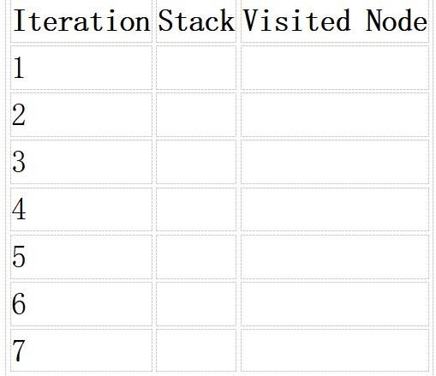
- Depth-First Search (DFS) Using the same graph,
A
/ \
B C
/ \ / \
D E F G
Perform Depth-First Search (DFS) starting from A. Complete the table.
- Initial State :
1 3 6
5 0 2
4 7 8

Goal State :
1 2 3
4 5 6
7 8 0

Task
Trace Breadth-First Search (BFS) until the goal state is reached. Fill in the table.

Iteration Current State Queue Before Expansion Queue After Expansion
1
2
3
4
5

Questions
- Which node is expanded in each iteration?
- How many states are generated in total?
- Write the complete solution path from the initial state to the goal state.
- Why does BFS always find the shortest solution in an unweighted 8-puzzle problem?

RUBRICS FOR CALCULATION

Criteria | Weightage (%) | Level 4 –  Exemplary (4) | Level 3 –  Proficient (3) | Level 2 –  Developing (2) | Level 1 –  Beginning (1)

Understandi ng of Search Problem | 20 | Clearly understands the search problem, initial state, goal state, and search  strategy. | Understands the problem with minor misunderstandin  gs. | Demonstrates partial understanding of the search problem. | Shows little or no understanding of the search  problem.
Criteria | Weightage (%) | Level 4 –  Exemplary (4) | Level 3 –  Proficient (3) | Level 2 –  Developing (2) | Level 1 –  Beginning (1)
State Expansion and Dry Run Execution | 30 | Correctly traces every iteration, expands nodes accurately, and maintains the Queue/Stack/Priority Queue without errors. | Performs most iterations correctly with minor mistakes in state expansion or data structure  updates. | Performs only some iterations correctly; several errors in tracing or node expansion. | Unable to correctly perform the dry run or expand states.
Application of Search Algorithm | 20 | Applies the selected algorithm (BFS/DFS/UCS)  correctly, following all algorithmic rules. | Applies the algorithm correctly with a few procedural  errors. | Applies only basic algorithm steps with noticeable mistakes. | Fails to apply the correct search algorithm.
Accuracy of Solution Path | 20 | Identifies the correct traversal order/solution path and goal state with  proper justification. | Solution path is mostly correct with minor errors. | Partially correct solution path; goal may not be reached correctly. | Incorrect or incomplete solution path.
Presentation and Logical Reasoning | 10 | Queue/Stack/Priority Queue updates, state diagrams, and explanations are neat, organized, and  logically presented. | Presentation is clear with minor organizational issues. | Limited explanation and organization; reasoning is partially clear. | Poor presentation with unclear or missing reasoning.

Breadth-First Search (BFS)

Aim
To perform Breadth-First Search on the given graph, starting from node A, and record the traversal order and queue contents after each iteration.

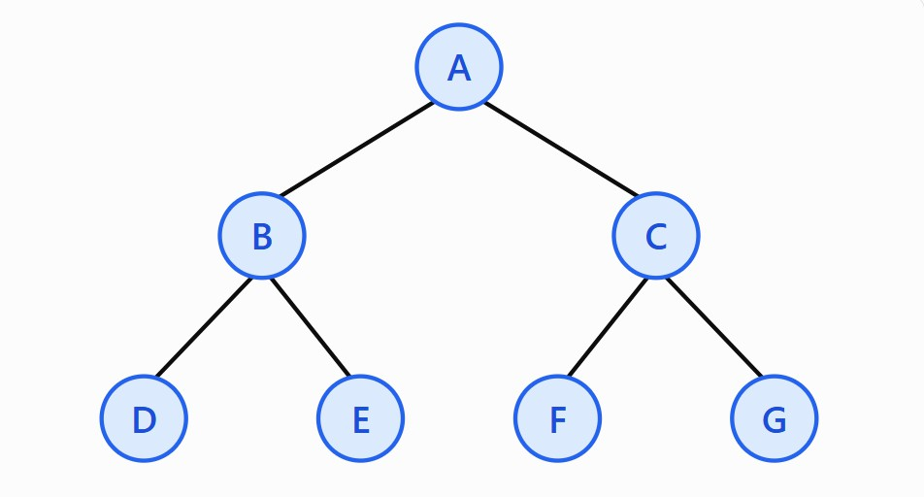
Given graph
The graph contains seven nodes: A, B, C, D, E, F, and G.
  - A is the root node.
  - B and C are the children of A.
  - D and E are the children of B.
  - F and G are the children of C.

Algorithm
BFS visits nodes level by level, from left to right. It uses a queue that follows the FIFO (First In, First Out) principle.
- Insert the starting node A into the queue.
- Remove the node at the front of the queue.
- Mark that node as visited.
- Insert its unvisited children at the rear of the queue, from left to right.
- Repeat until the queue is empty.

Detailed dry run
Iteration | Node removed and visited | Queue after expansion | Visited nodes
1 | A | B, C | A
2 | B | C, D, E | A, B
3 | C | D, E, F, G | A, B, C
4 | D | E, F, G | A, B, C, D
5 | E | F, G | A, B, C, D, E

6 | F | G | A, B, C, D, E, F
7 | G | Empty | A, B, C, D, E, F, G

Step-by-step explanation
Iteration 1: The queue initially contains A. Remove A and visit it. Add its children B and C. The queue becomes [B, C].
Iteration 2: Remove B and visit it. Add its children D and E behind C. The queue becomes [C, D, E].
Iteration 3: Remove C and visit it. Add its children F and G. The queue becomes [D, E, F, G]. Iteration 4: Remove D and visit it. D is a leaf node, so no new nodes are added. The queue becomes [E, F, G].
Iteration 5: Remove E and visit it. Since E has no children, the queue becomes [F, G].
Iteration 6: Remove F and visit it. The queue becomes [G].
Iteration 7: Remove G and visit it. The queue becomes empty, so the algorithm terminates.
- Answers to the questions

Write the BFS traversal order.
A → B → C → D → E → F → G

Show the queue contents after each iteration.
  - After iteration 1: [B, C]
  - After iteration 2: [C, D, E]
  - After iteration 3: [D, E, F, G]
  - After iteration 4: [E, F, G]
  - After iteration 5: [F, G]
  - After iteration 6: [G]
  - After iteration 7: []
Result: BFS visits all seven nodes in level order, starting from A.

Depth-First Search (DFS)

Aim
To perform Depth-First Search on the same graph, starting from node A, and record the order in which nodes are visited.

Principle
DFS explores one branch as deeply as possible before returning to explore another branch. It uses a stack (Last In, First Out) or recursion.
For this assessment, we visit the left child before the right child.

Algorithm
- Start at node A.
- Mark A as visited.
- Move to the leftmost unvisited child.
- Continue deeper until reaching a node with no unvisited children.
- Backtrack to the nearest node with an unvisited child.
- Continue until all nodes have been visited.

DFS traversal diagram

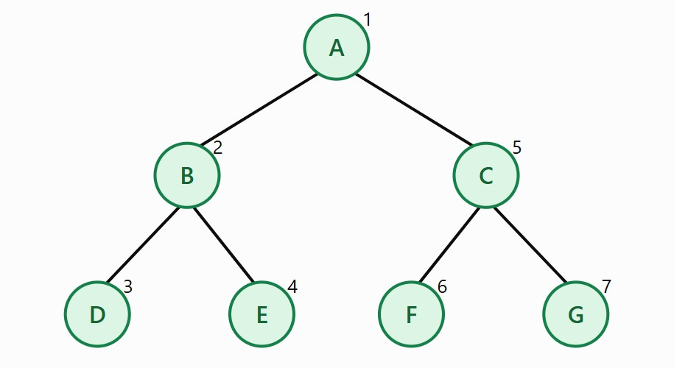

Detailed dry-run table

Iteration | Node visited | Action performed | Visited order
1 | A | Move to left child B | A
2 | B | Move to left child D | A, B
3 | D | Leaf node; backtrack to B | A, B, D
4 | E | Visit right child of B; backtrack | A, B, D, E
5 | C | Backtrack to A and enter right subtree | A, B, D, E, C
6 | F | Visit left child of C | A, B, D, E, C, F
7 | G | Visit right child of C | A, B, D, E, C, F, G

Step-by-step explanation
Iteration 1: Start at A and mark it as visited. Move to B. Iteration 2: Visit B. Move deeper into its left child D. Iteration 3: Visit D. It has no children, so return to B.
Iteration 4: Visit E, the right child of B. E is also a leaf, so return to A.
Iteration 5: Move to C, the right child of A.
Iteration 6: Visit F, the left child of C. Since F has no children, backtrack to C.
Iteration 7: Visit G, the right child of C. All nodes have now been visited.

Answers to the questions
- Write the DFS traversal order. A → B → D → E → C → F → G

Explain how DFS works.
DFS goes as deep as possible along one branch. When it reaches a leaf or a node without unvisited children, it backtracks and explores the next available branch.
Result: DFS visits all seven nodes by completely exploring the left subtree before the right subtree.

8-Puzzle Problem Using BFS

Aim
To solve the 8-puzzle problem using Breadth-First Search, starting from the given initial state and reaching the goal state. The task involves tracing the queue, identifying expanded states, and finding the shortest solution path.

Initial state and goal state
The 8-puzzle consists of eight numbered tiles and one blank space represented by 0. A legal move slides a tile into the blank space.
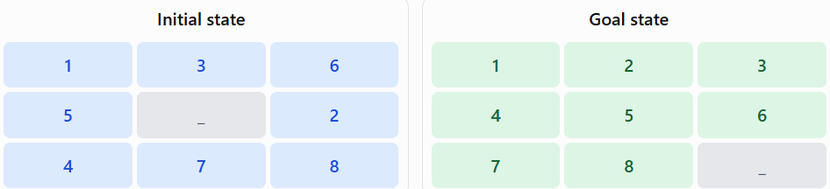
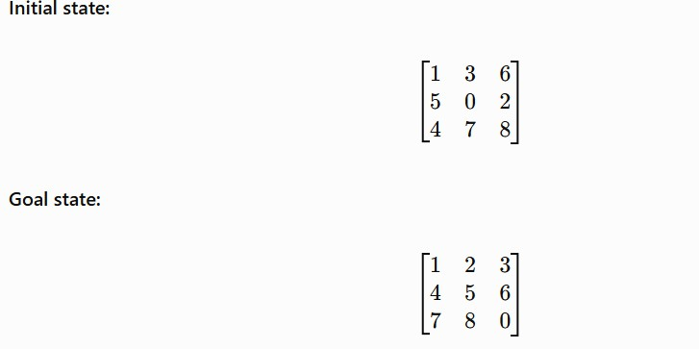
_

BFS algorithm for the 8-puzzle
- Insert the initial state into a FIFO queue.
- Mark the initial state as discovered.
- Remove the state at the front of the queue.
- Check whether the current state matches the goal.
- If it does not, generate all legal blank moves.
- Add new states that have not been discovered to the rear of the queue.
- Store each state's parent and move so that the solution path can be reconstructed.
- Continue until the goal state is reached.

For the dry run below, successors are generated in this order: Up → Down → Left → Right. Illegal moves and previously discovered states are skipped.

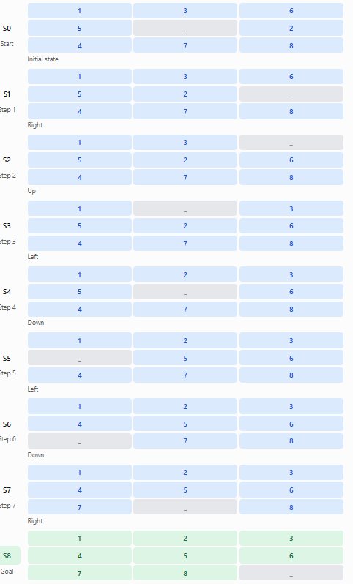
Detailed solution path
Right – Goal reached
The blank space moves in the following order:
Right → Up → Left → Down → Left → Down → Right → Right
The path has nine states, including the initial and goal states, and requires eight moves.

BFS queue dry run: first five iterations
The assessment asks for the current state, queue before expansion, and queue after expansion. To keep the table readable, the states below use short labels.

Label | Board state
S0 | 136 / 502 / 478
U1 | 106 / 532 / 478
D1 | 136 / 572 / 408
L1 | 136 / 052 / 478
R1 | 136 / 520 / 478
In these labels, each three-digit group represents one row. For example, 136 / 502 / 478 means the rows are 1 3 6, 5 0 2, and 4 7 8.

Dry-run table
Iteration | Current state  expanded | Queue before expansion | Queue after expansion
1 | S0 | [S0] | [U1, D1, L1, R1]
2 | U1 | [U1, D1, L1, R1] | [D1, L1, R1, U2, UR2]
3 | D1 | [D1, L1, R1, U2, UR2] | [L1, R1, U2, UR2, DL2, DR2]
4 | L1 | [L1, R1, U2, UR2, DL2, DR2] | [R1, U2, UR2, DL2, DR2, LU2, LD2]
5 | R1 | [R1, U2, UR2, DL2, DR2, LU2, LD2] | [U2, UR2, DL2, DR2, LU2, LD2, RU2, RD2]
The additional labels denote newly generated states:
- U2, UR2: states generated from U1.
- DL2, DR2: states generated from D1.
- LU2, LD2: states generated from L1.
- RU2, RD2: states generated from R1.
Only newly discovered states are added to the queue. A state already discovered is not inserted a second time.
Important: The five rows above show the first five expansions, not the complete search. BFS continues expanding states in FIFO order until the goal state is dequeued.

Answers to the questions
- Which node is expanded in each iteration?
During the first five iterations, the expanded states are:
  - S0 – the initial state.
  - U1 – the state generated by moving the blank up.
  - D1 – the state generated by moving the blank down.
  - L1 – the state generated by moving the blank left.
  - R1 – the state generated by moving the blank right.
After these iterations, BFS continues with the remaining states in queue order until it reaches the goal.

How many states are generated in total?

Using the stated successor order, counting the initial state and counting each unique discovered board only once, the search discovers 500 unique states by the time the goal is dequeued. Of these, 311 states are expanded, including the goal state.
The number can differ if an assessment uses a different definition of “generated state,” such as counting repeated successor attempts or excluding the initial state.

Write the complete solution path from the initial state to the goal state. The shortest path is:
S0 → S1 → S2 → S3 → S4 → S5 → S6 → S7 → S8 The blank-space moves are:
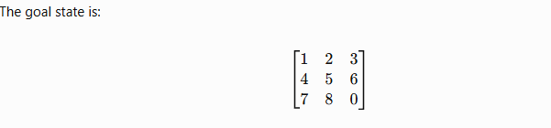
Right → Up → Left → Down → Left → Down → Right → Right The goal state is:

- Why does BFS always find the shortest solution in an unweighted 8-puzzle problem? BFS explores states in increasing order of depth. It first explores the initial state, then all states one move away, then all states two moves away, and so on.
Since every legal move has equal cost, the first goal state reached has the minimum number of moves. Therefore, BFS guarantees a shortest solution when the state space is finite and duplicate states are handled correctly.
Final conclusion
Breadth-First Search explores nodes level by level using a queue, while Depth-First Search explores deeply along one branch before backtracking. In the 8-puzzle problem, BFS systematically explores states and identifies a shortest solution of eight moves for the given initial and goal states.
Both BFS and DFS are fundamental AI search algorithms. BFS is suitable when the shortest path is required in an unweighted problem, whereas DFS is useful for exploring search trees with lower memory requirements in many cases.

